Katie Perkins

Midterm Project Deliverable

IS 601

User View:

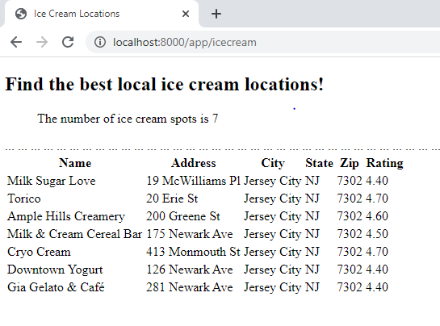

Admin View:

